
TransTec
Using TransTec

Contents

CHAPTER 1 3
TransTec Software 3
Installing TransTec 3
Get acquainted with the work environment 3
CHAPTER 2 5
Interface general presentation 5
Procedures / Manipulations 5
Create a new parcel 6
Parcel Check 7
Add a load list 8

CHAPTER 3 9
Interface general presentation 10
Procedures / manipulations 10
Create a load 10
Edit a load 11
Modify a load 12
Validate a load 12
Print a label 12
Enclose the preparation 13
Show an indident 13

CHAPTER 4 14
Interface general presentation 14
Procedures / Manipulations 15
Trucks management 15
Parcel distribution by destination 16
Incidents management 18
Routing table management 19
Users list management 21
Warehouse list management 22

CHAPTER 5 23
Glossary of the terms and abbreviations 23
List of the error message 23

CHAPTER 1
Presentation

TransTec Software

TransTec allows to manage the platforms of logistic transit. The company arranges several platforms of transit distributed on the area covered by the logistic service. On every transit platform we arrange:
- Entry posts to take into account parcel entering the platform, from the other transit platforms or entered locally,
- Supervision system allowing to optimize the trucks movements between the various platforms, and to manage incidents,
- Preparation posts and followed by the load of trucks.

The various posts access is done by the same interface of « Login ». According to his rights of access, the user will be directed towards his posts.

Installing TransTec

L’installation du logiciel TransTec une machine de configuration suivante :
- Intel Pentium Processeur
- Microsoft Windows XP Professionnel ou Édition Familiale (Service Pack 1 ou 2), Windows 2000 (Service Pack 2), Windows XP Édition Tablet PC, Windows Server 2003 ou Windows NT (Service Pack 6 ou 6a)
- 128 Mo de RAM (256 Mo recommandés)
- Jusqu'à 90 Mo d'espace disque disponible
- Microsoft Internet Explorer 5.5 (ou version ultérieure), Netscape 7.1 (ou 8.0), Firefox 1.0 ou Mozilla 1.7
To install TransTec :
  - Insert the TransTec CD into your computer’s CD-ROM drive
  - Do one of the following:
    - In Windows, the TransTec installation program starts automatically.
    - On the Macintosh, double-click the TransTec Installer icon..
  - Follow the onscreen instructions
    - The installation program prompts you to enter the required information.
  - If prompted, restard your computer.

Get acquainted with the work environment

When you open for the first time TransTec, a login window appears. This window allow to reach three environments: « entry post », « assistant post » and « superintendent post », according to the login and password.

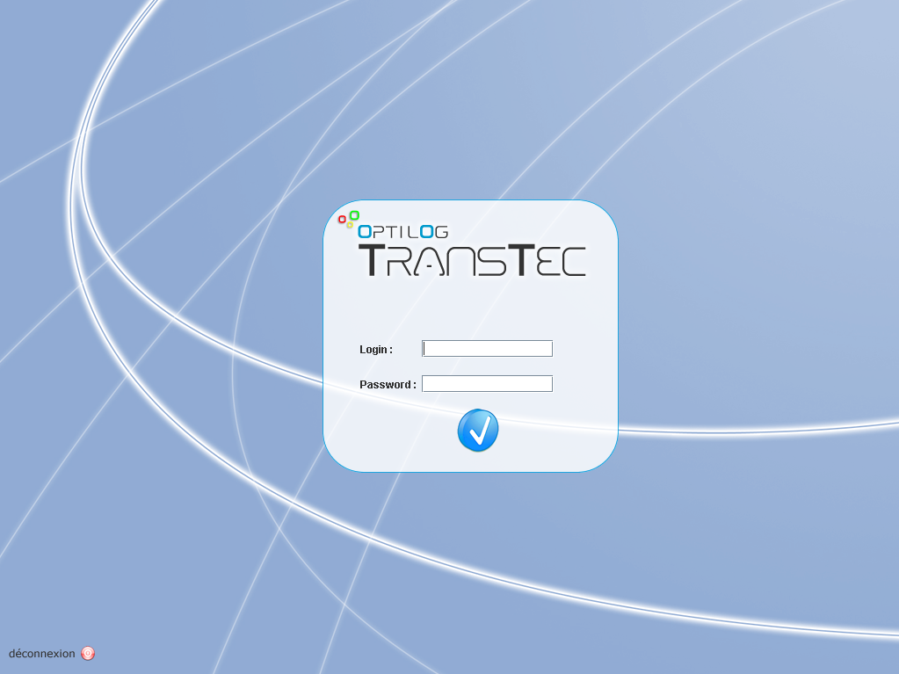
- Login window - TransTec

CHAPTER 2
Entry post

Interface general presentation

The entry post interface consists of three main windows. The window « Actions », always placed on the the right of the screen, assure the functions appropriate for the parcel. The window center represents the selected parcel information, the incidents and its load.

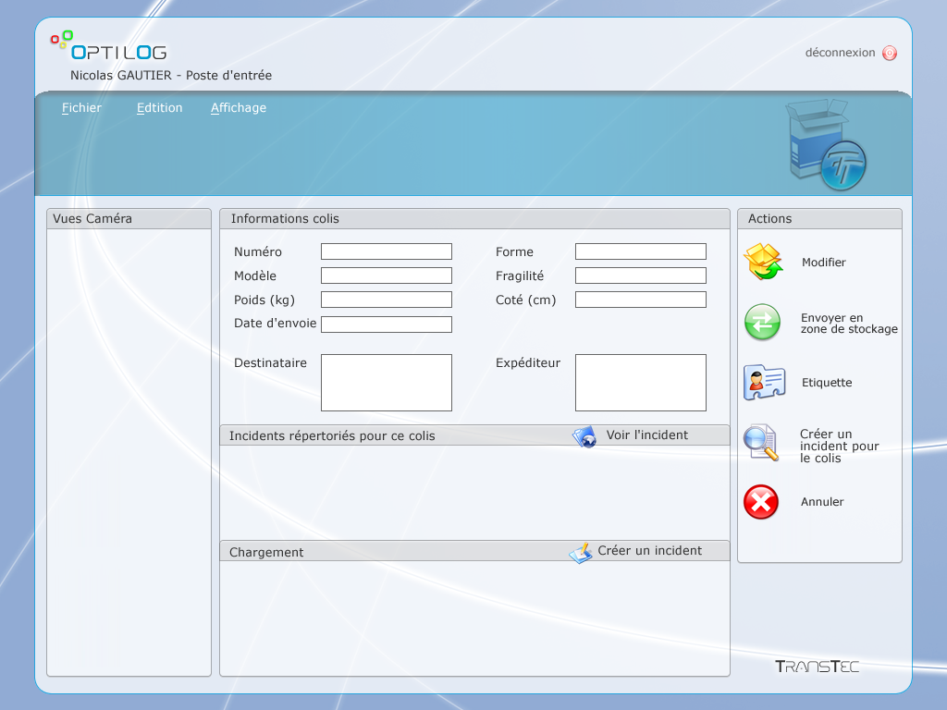
- Entry post, main window - TransTec

Procedures / Manipulations

Create a new parcel

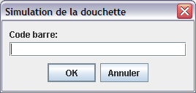
- Entry post, steer code simulation window - TransTec

You are in the « steer code simulation window » of the entry post.
- Click on the button « Annuler ».
You are in the « main window » of the entry post.
- Seize the information concerning the new parcel.
- Seize the sender and the addressee of the parcel. You have two possibilities to seize this information:
  - By seizing the fields of information manually.
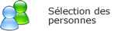
  - Or by selecting persons already seized in the data base by clicking the button “Sélection des personnes”.

You are in the window « sender and/or addressee selection » of the entry post.
    - Add an addressee by selecting an entry in the list then by clicking the button « Ajouter le destinataire ».
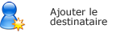
    - Add a sender by selecting an entry in the list then by clicking the button « Ajouter l’expéditeur ».
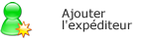

    - Once these two persons were selected, click the button « Fermer » to validate and return to the main window.


- Print the label corresponding to the parcel by clicking the button « Etiquette »


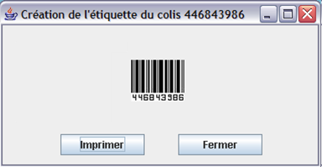

- Entry post, label creation window - TransTec

Parcel Check
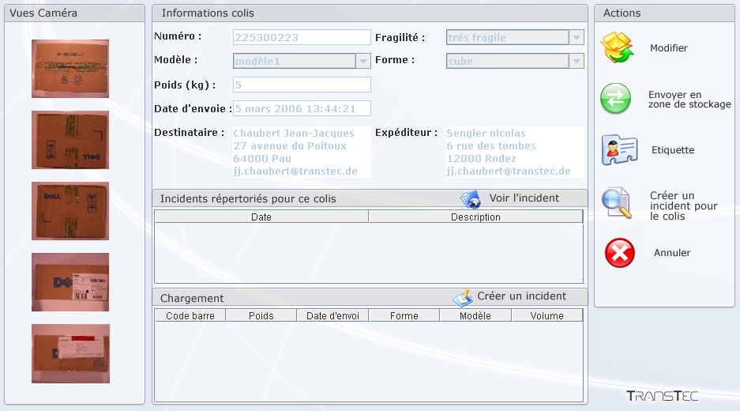

You are in the « steer code simulation window » of the entry post.
- Seize the steer code of the parcel to verified, then click the button « OK »
You are in the « main window » of the entry post.
- The parcel information displays on the screen.
- You have the possibility to do four actions in touch with this parcel
  - Modify the information parcel.


  - Creation of an incident for the parcel then send it to stocking zone.
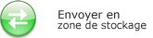

  - Create the corresponding label then print it.

  - Show the incidents already draft for this parcel.
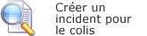

NOTE : By clicking the button cancel, you leave this menu and return to the window « steer code simulation window »


Add a load list

You are in the « steer code simulation window » of the entry post.
- Seize the steer code of the load to add, then click the button « OK »
You are in the « main window » of the entry post.
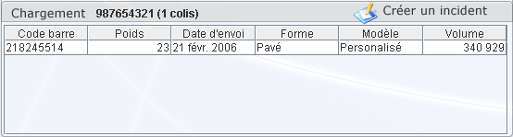
- Parcels presents in this load displays in the window « Load », as it is show below:

- Entry post, load window - TransTec

- You have the possibility to create an incident for a parcel which has been not found in the load :
  - Select a parcel in the window « load ».
  - Click the button « Créer un incident » :

You are in the « incident creation window » of the entry post.
  - Seize your comment on the parcel.

CHAPTER 3
Preparation post

Interface general presentation

The preparation post interface consists of two main windows. The window “Actions”, always placed on the the right of the screen, assure the functions appropriate for the parcel or for the load. The window center represents the information of the selected load.

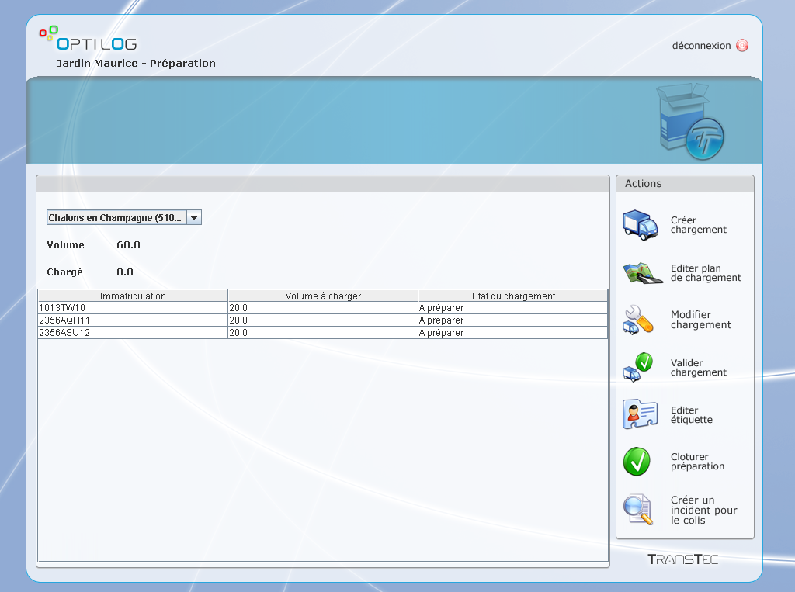
- Preparation post, main window - TransTec

Procedures / manipulations

Create a load

You are in the « main window » of the preparation post.
- Select a destination in the left window.
- Select a load in the list then click the button « Créer chargement » in the right window « Actions » :
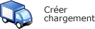

You are in the « load creation window » of the preparation post.
- This window allows you to feign your truck load. By selecting parcel in the left window “Aperçu colis” you can add them to the load by means of buttons:



- Once the parcel added, you can move it with the keyboard direction arrows.
- Finally, click on the icon « Valider » to validate the load creation. This action is going to create a temporary load.


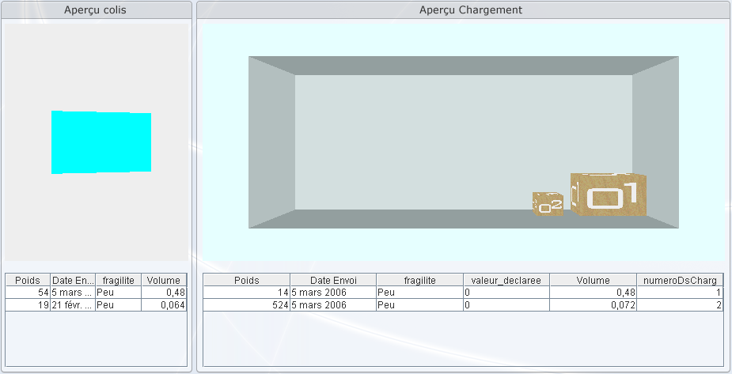

Edit a load

You are in the « main window » of the preparation post.
- Select a destination in the left window.
- Select a load in the list then click the button « Editer plan de chargement » in the right window » Actions ».
- By clicking the following button you are going to display the load plan for the attention of the packers :

NOTE : By clicking this button you will still have the possibility to modify the load afterward.
- Use the button « Imprimer » to print the plan load.


Modify a load

You are in the « main window » of the preparation post.
- Select a destination in the left window.
- Select a load in the list then click the button « Modifier chargement » in the right window » Actions ».


- By clicking the button above you have the possibility to add, remove and move again the load parcel.

Validate a load

You are in the « main window » of the preparation post.
- Select a destination in the left window.
- Select a load in the list then click the button « Valider chargement» in the right window » Actions ».
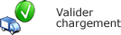

NOTE : Having to confirm the validation of your load, this one is not modifiable anymore.

Print a label

You are in the « main window » of the preparation post.
- Select a destination in the left window.
- Select a load in the list then click the button « Imprimer une étiquette » in the right window « Actions » to print the load validated label.

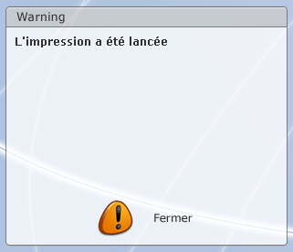

Enclose the preparation

You are in the « main window » of the preparation post.
- Select a destination in the left window.
- Select a load in the list then click the button « Cloture préparation » in the right window « Actions » to enclose the load.


- The preparation of the load is now finalized.

Show an indident

You are in the « main window » of the preparation post.
- Select a destination in the left window.
- Select a load in the list then click the button « Afficher archive » in the right window « Actions » to show an incident.


NOTE: At any time the user can see or add an incident for a parcel.

CHAPTER 4
Superintendent post

Interface general presentation

The superintendent post allows:
- The trucks management (first tab)
- The parcel distribution by destination (the second tab)
- The incidents management (the third tab)
- The routing table management (the fourth tab)
- The users list management (the fifth tab)
- The warehouses management (the sixth tab)
For each tab (below detailed), the window « actions » in the left screen side, will assist you in your manipulations.

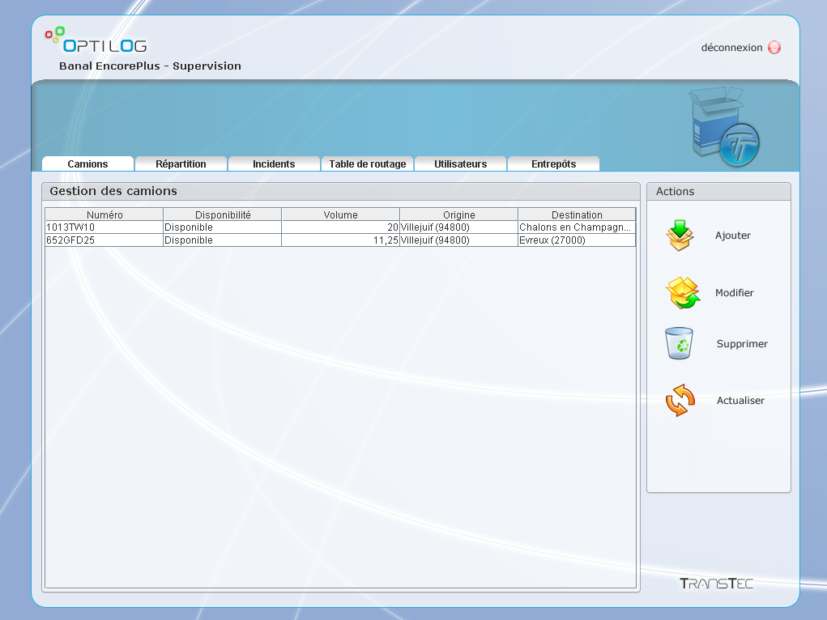
- Superintendent post, main window - TransTec

Procedures / Manipulations

Trucks management
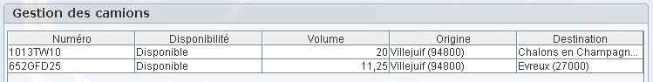

- Superintendent post, trucks management window - TransTec

You are in the « trucks management window » of the superintendent post.

- To add a new truck to the list, click the button « Ajouter » :

- Then seize the fields of the following dialogue window, then click the button “validate”:
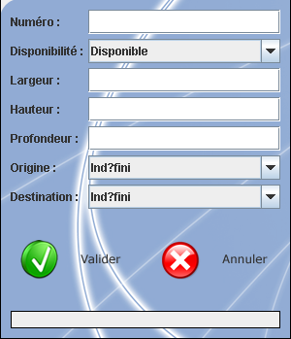

After validation, the truck appears in the management list.


- To do the « modify », « delete » actions, select a truck in the list and follow the instructions.

NOTE : The truck selected deletion pulls its definitive deletion : no confirmation will be asked.

Parcel distribution by destination
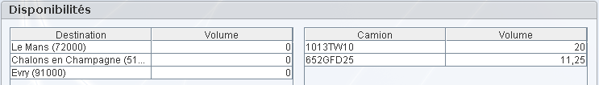

- Superintendent post, parcel distribution window - TransTec

You are in the « distribution window » of the superintendent post.
- The main distribution window of the parcel informs the user of the useful resources for the distributions, by showing the available trucks and the destinations for wich there is parcel to transport.

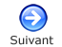
Click the button « suivant » in the window “Actions” to reach the second step.

You are in the « distribution algorithm choice window » of the superintendent post.
- Select a distribution algorithm, knowing that :
  - No algorithm: you choose the trucks which are going to travel as well as their destinations. No optimization proposition will be made by the system.
  - Skinflint algorithm: The system looks for the slightest cost solution by minimizing the sum of kilometres multiplied by the volume of trucks. The system will propose destinations in the following step.
  - Santa Claus algorithm: the system looks for the distribution which allows to transport the maximum volume during the day (customer satisfaction). The system will propose destinations in the following step.
Click the button « suivant » in the window “Actions” to reach the third step.

NOTE: If you choose an algorithm, the system will propose a destination in the third step but you will always have the possibility to modify it.

ATTENTION: If you choose the skinflint algorithm, watch that there is indeed a destination which can fill totally a truck, in which case the truck will not appear in the third step.

You are in the « distribution window » of the superintendent post.
- If no algorithm was selected in the previous step, select a destination for each truck. Select also a user for every preparation.
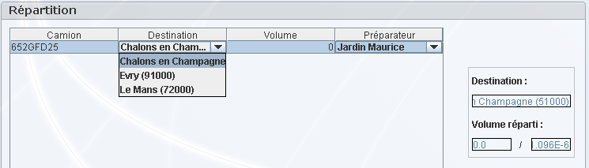

NOTE: It is possible to modify the truck volume by clicking the board corresponding cell.

- Then click the button « Publier », in the window « Actions » to return the preparations available to the user.


Incidents management
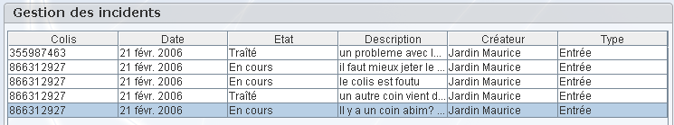

- Superintendent post, Incidents window - TransTec

You are in the « incidents window » of the superintendent post.

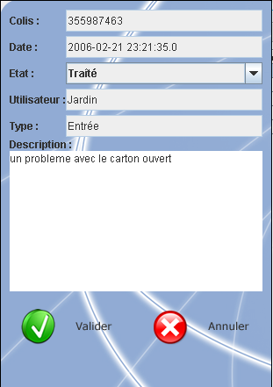
- Select an incident in the board and click the button « Afficher », in the window « Actions » to show the details of the incident.

In this window, you have the possibility to modify the incident state in “treaty”, “not treaty” or “in progress”.
Click the button “Valider” to save the modifications.

You are in the « incidents window » of the superintendent post.
- Click the button « modifier », you change the incident selected from the state “not treated” in “in progress” or from “current” state in “traty”.

Routing table management
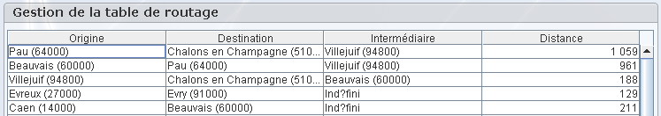

- Superintendent post, Routing table window - TransTec

You are in the « Routing table window » of the superintendent post.
- To add a new entry to routing table list, click the button « Ajouter » :
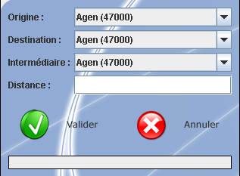

Then seize the fields of the following dialogue window, and then click the button “Valider”

- To modify a selected entry of routing table list, click the button “Modifier”:
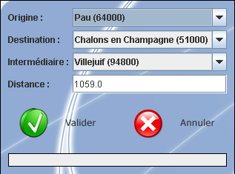

Then seize the fields of the following dialogue window, and then click the button “Valider”

- To delete a selected entry of the routing table, click the button “Supprimer”

NOTE: The entry deletion pulls its definitive deletion: no confirmation will be asked.

Users list management
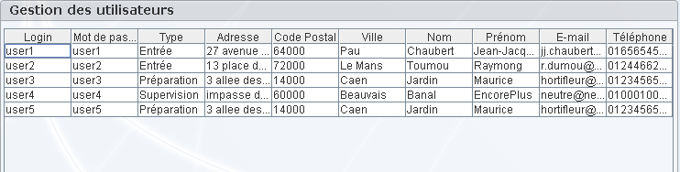

- Superintendent post, Users list management window - TransTec

You are in the « Users list management window » of the superintendent post.
- To add a new user to the list, click the button « Ajouter » :
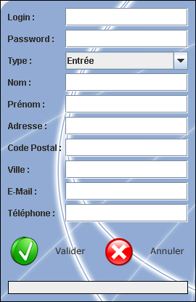

Then seize the fields of the following dialogue window, and then click the button “Valider”

- To modify a selected user of the list, click the button “Modifier”:
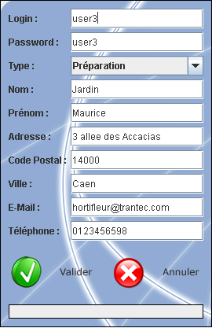

Then seize the fields of the following dialogue window, and then click the button “Valider”

- To delete a user from the list, click the button “Supprimer”

NOTE: The user deletion pulls its definitive deletion: no confirmation will be asked.

Warehouse list management

NOTE: The warehouse list management is made in the same way as the user management list. Refer to” the user list management.”

CHAPTER 5
Appendices

Glossary of the terms and abbreviations

List of the error message

www.optilog.fr

